PEOPLE FIRST
STATE OF FLORIDA BENEFITS
NEW HIRE
ENROLLMENT INSTRUCTIONS
People First Service Center: 1-866-663-4735 Monday through Friday, 8 a.m. to 6 p.m. E.T.
①  - log on: https://peoplefirst.myflorida.com  - People First ID (mailed by People First) and Password (first Log On PfMMDDYY – Example: Date of Birth is August 15, 1967; initial log on Pf081567) | 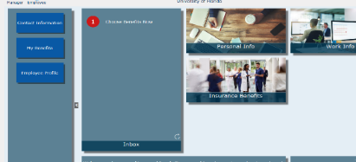  ②  - Employee Landing Page – Choose Benefits Now (Inbox) | 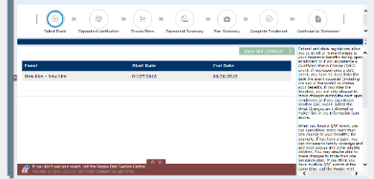  ③  - Click New Hire – Save and Continue
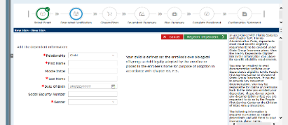  ④  - Dependent Verification - click on  register a new dependent (+) sign to add dependents: add Relationship; First Name; Last Name; Date of Birth and Gender – Save and Continue | 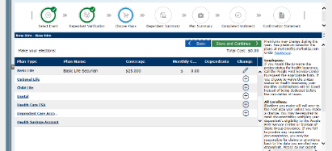  ⑤  - Choose Plans – click the (+) to add plans–use the drop down arrow to choose the new election.  - – Save | 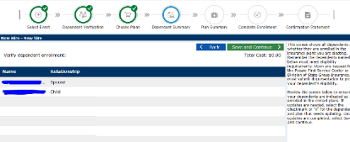  ⑥  - Dependent Summary - Review this screen to ensure your dependents are enrolled in the correct plans. - Save and Continue.
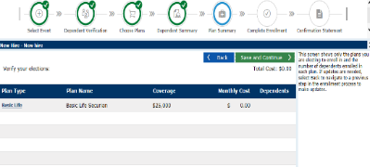  ⑦  - Verify your elections – Save and Continue | 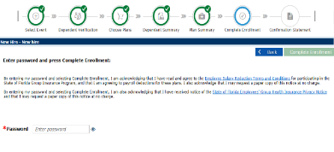  ⑧  - Enter Password – Complete Enrollment | 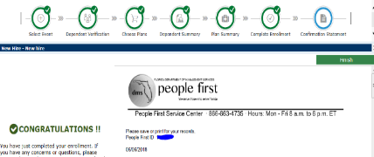  ⑨  - Confirmation Statement – Print or Save Confirmation Letter - Finish

